We are given the prices of k products over n days, and we want to buy each product exactly once.However, we are allowed to buy at most one product in a day.What is the minimum total price ? For example, consider the following scenario(k = 3 and n = 8):
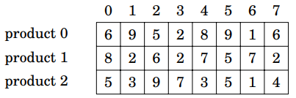
In this scenario, the minimum total price is 5:
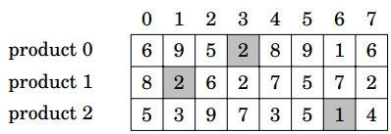
#include <iostream>
#include <climits>
using namespace std;
int main() {
int k, n;
cin >> k >> n;
int price[k][n];
for (int i = 0; i < k; ++i)
for (int j = 0; j < n; ++j)
cin >> price[i][j];
int dp[1 << k][n];
for (int x = 0; x < k; ++x)
dp[1 << x][0] = price[x][0];
for (int d = 1; d < n; ++d) {
for (int s = 0; s < (1 << k); ++s) {
dp[s][d] = dp[s][d - 1];
for (int x = 0; x < k; ++x) {
if (s & (1 << x))
dp[s][d] = min(dp[s][d], dp[s ^ (1 << x)][d - 1] + price[x][d]);
}
}
}
int res = INT_MAX;
for (int s = 0; s < (1 << k); ++s)
if (dp[s][n - 1] != 0)
res = min(res, dp[s][n - 1]);
cout << res;
return 0;
}

